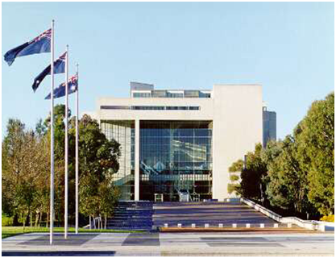
High Court Canberra

Registry Counter Officer HCE Level 3
Non-ongoing Full-time position
Sydney
$61,169 - $65,891pa
plus 15.4% Superannuation

This position is located in Sydney in the Law Courts Building in Queens Square and is a part of the High Court’s Registry Branch. The Registry is responsible for providing information and assistance to legal practitioners and litigants on the jurisdiction, practice and procedure of the High Court. It is also responsible for the filing of proceedings and for collecting and accounting for all fees received by the Court.

ABOUT THE JOB

Details: High Court Employee Level 3
Full Time: 37.5 hours a week
Salary: $61,169 - $65,891pa plus 15.4% Superannuation
Location: Sydney

The Role
Under routine direction the occupant of this position will perform a range of tasks that contribute to the smooth daily operations of the High Court Registry in Sydney.
Contact Officer
If you have any questions please contact Adam Griffin, Deputy Registrar.

Telephone 02 9230 8375

Email: hr.officer@hcourt.gov.au

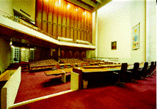Court room 1

THE ROLE
Under routine direction the occupant of this position will perform a range of tasks that contribute to the smooth daily operations of the High Court Registry in Sydney including:

- Attending to telephone and counter enquiries. Providing information and assistance to legal practitioners and members of the public regarding matters filed in the Court.

- Receiving and dispatching incoming documents both by courier and post.

- Receiving and accounting for statutory fees and charges for services and goods provided by the Court.

- Ensuring the timely distribution and collation of Court documents as required. Under supervision, assisting with the maintenance of the Digital Lodgment System. Assisting in initial checking of filed documents for compliance with the requirements of the High Court Rules.

- Providing administrative assistance to the Deputy Registrars.

- Assisting practitioners seeking to enter their names on the Register of Practitioners.

SELECTION CRITERIA
Please concisely describe your skills and experience against the following selection criteria. You are encouraged to use dot points.
- Well-developed oral and written communication skills, including the
ability to respond appropriately to inquiries from practitioners, unrepresented litigants and members of the public.
- Knowledge of or the ability to acquire knowledge of, court processes.
- A high degree of computer literacy.
- Effective organisational skills, including the ability to meet deadlines and prioritise workloads in a small team environment.
- A demonstrated high level of accuracy and attention to detail.

Qualifications and experience:

  - Experience working in a legal environment, or a court or tribunal registry, is desirable.

Mandatory:

  - Must be an Australian Citizen

HOW TO APPLY

For your application to be considered, it must include the following documents:
- an application cover sheet (refer page 7)
- a covering letter
- your current resume
- a statement addressing the selection criteria

Preference is for electronic lodgement of applications by email to the HR Manager, hr.officer@hcourt.gov.au . If you do not have email access, a hard copy application may be lodged by post to:
HR Manager
High Court of Australia
PO Box 6309
KINGSTON ACT 2604

The closing date for applications is 5:00pm Wednesday 27 April 2021
Applicants are advised that late or incomplete applications will not be accepted.

Court room 1 front doors

CONDITIONS OF ENGAGEMENT

Employees of the Court are employed under the High Court of Australia Act 1979, with the Determination under s26 (4) of the High Court of Australia Act 1979 Terms and Conditions of Employment of Employees.
The following pre-employment checks will be conducted prior to the commencement of employment:
Australian citizenship evidenced by an Australian birth certificate or passport, or a certificate of Australian citizenship for applicants born overseas.
A 100 point identity check. In the case of a name change, a marriage certificate, deed poll or other legal evidence must also be provided.
A previous employment/reference check.
A criminal history check.
A pre-employment medical exam.
All employees are subject to a 6 month probationary period.

Commonwealth/APS/State Government Employment
The High Court of Australia is not an APS employer, however will recognise prior service with qualifying government employers.

HIGH COURT OF AUSTRALIA
APPLICATION COVER SHEET
Position Title: | Registry Counter Officer- Sydney  Full Time | Position Classification: | HCE Level 3  Non-Ongoing
Personal Details
Title |  | Surname
Given Names |  | Date of Birth  (optional)
Postal Address
Contact Phone No (business hours)
Email Address
You must be an Australian citizen to be eligible for employment at the High Court of Australia.
Do you have any restrictions that may prevent your employment with the High Court? Yes/no
Are you an Australian citizen? (Please circle or delete) YES / NO
Do you require assistance in attending an interview? Yes/No if yes please advise your requirements

Are you currently a Commonwealth, APS or State government employee? (Please circle) Department/Agency name: |  |  |  | YES / NO
AGS number
Nominal Level |  | Actual Level
Ongoing Employee | Yes/No | Non-ongoing employee | Yes/No
Have you received a redundancy from a Commonwealth, APS or state government employer in the last 12 months? (Please circle or delete) |  |  | YES / NO

Referee 1 Details |  |  | Referee 2 Details
Name: |  |  | Name:
Title: |  |  | Title:
Organisation: |  |  | Organisation:
Phone No: |  |  | Phone No:

