High Court of Australia

How to inspect a file or obtain copies of documents

Click on the public search either on the public portal:
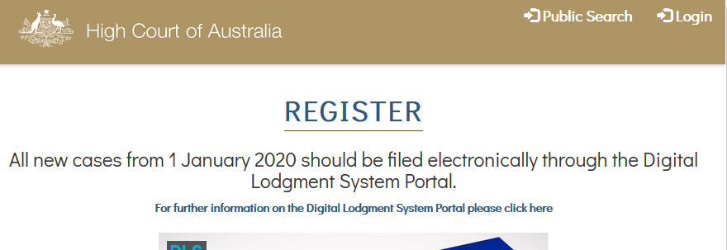

or within the DLS Portal if you are logged in.

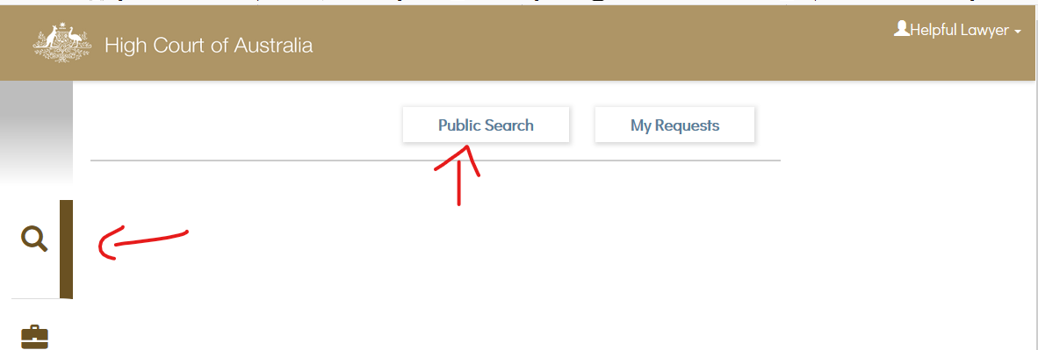

Enter the search term you wish to use; this will return any results as a list.
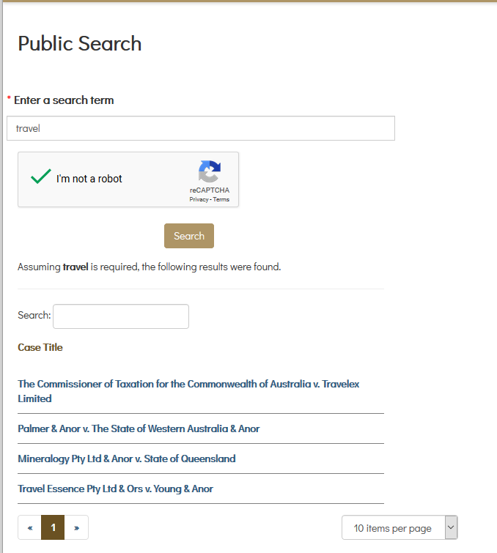

Select the matter you wish to view. This will open a list of documents filed in the matter which may be available to view or inspect:
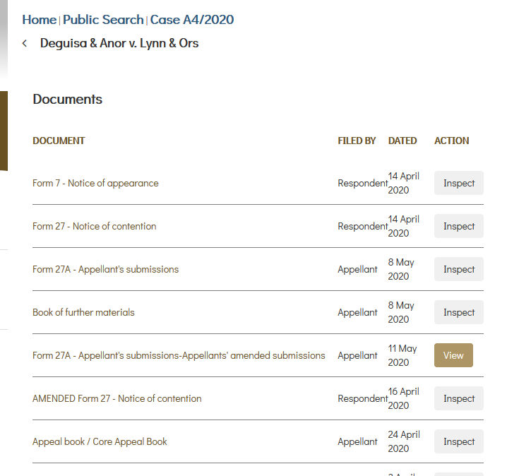

Some documents for matters to be heard by the Full Court are available free of charge. Transcripts and Judgments are also available without charge. If a document is available there is a view button.

Inspecting a file
There is a $29.00 search fee to inspect the file, this gives you access for 1 hour to the file. You will be asked if you wish to proceed to viewing the file, if you accept and continue you will be asked to pay by credit card before access is granted:
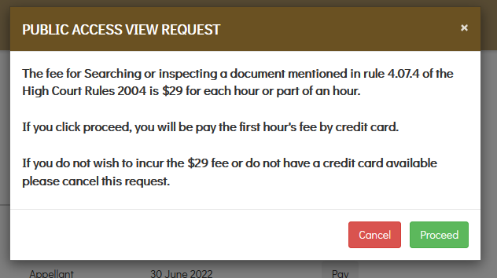

Downloading a document
If you wish to download a document click onto the document name. This will open another window which will advise of the costs of obtaining a download copy of the document. This request will need to be approved by the Registry; it is not instant. Again, you will be asked to pay before access is granted.

If your application is approved, you will be sent an email with a link to access the document. Alternatively, you can go into your user account and it will appear in the “my searches” area. The document is available for download for 24 hours.

